Innovate with Microsoft 365 Copilot and build your own agents (WS)
End
InstructionsResources
If you have to copy multiple lines within a code block into an application or cloud shell prompt, consider using Notepad as an intermediate step by doing the following:
- Open Notepad.
- Select the symbol beside the code block to copy the code block into Notepad.
- Select the lines of code you copied into Notepad and paste them into the application or cloud shell prompt.

Lab 7 - Build MCP-Powered Agents in Microsoft Copilot Studio
Scenario:
Zava, a fast-growing digital health organization, has recently formed an Internal Innovation Hub to experiment with new AI capabilities that could later be adapted into regulated healthcare solutions. Before connecting sensitive medical systems, the innovation team needs a safe, low-risk sandbox to learn how to integrate external APIs and data sources with Microsoft Copilot Studio using the Model Context Protocol (MCP).
To do this, the team starts with a simple, harmless example - a Jokes MCP Server - that demonstrates how Copilot Studio can call real-time APIs through MCP. This lightweight prototype helps engineers, data scientists, and AI solution architects understand:
- how MCP servers are deployed to Azure,
- how Copilot Studio can discover and consume MCP tools, and
- how real-time external data can be securely integrated into agents.
By completing this lab, the Zava Innovation team establishes the foundation for connecting future MCP servers to real business systems - once governance and compliance measures are applied.
Business Value:
- Encourages hands-on learning with MCP integration before applying it to sensitive domains.
- Demonstrates end-to-end deployment and tool consumption in a secure, Azure-ready setup.
- Builds organizational readiness for next-generation, AI-driven workflows.

Objective:
In this lab, you will simulate how Zava's Innovation Hub experiments with the Model Context Protocol (MCP) to connect external APIs and knowledge sources with Microsoft Copilot Studio. You'll learn how to deploy an MCP Server to Azure, register it as a tool in Copilot Studio, and integrate it into a conversational agent.
By completing this lab, you will:
- Understand how MCP enables secure, real-time data integration for Copilot Studio agents.
- Learn to deploy, configure, and connect an MCP Server using Azure Developer CLI.
- Explore the end-to-end workflow of adding an MCP-powered tool to a Copilot Studio agent.

Exercise 1: Deploy the MCP Server to Azure
In this exercise, you will deploy the Microsoft MCP (Model Context Protocol) Server from a local development environment to Azure using the Azure Developer CLI (azd). This establishes a cloud-hosted endpoint that can be consumed by Copilot Studio or other applications in later exercises.
- Open Docker Desktop from the lab VM.
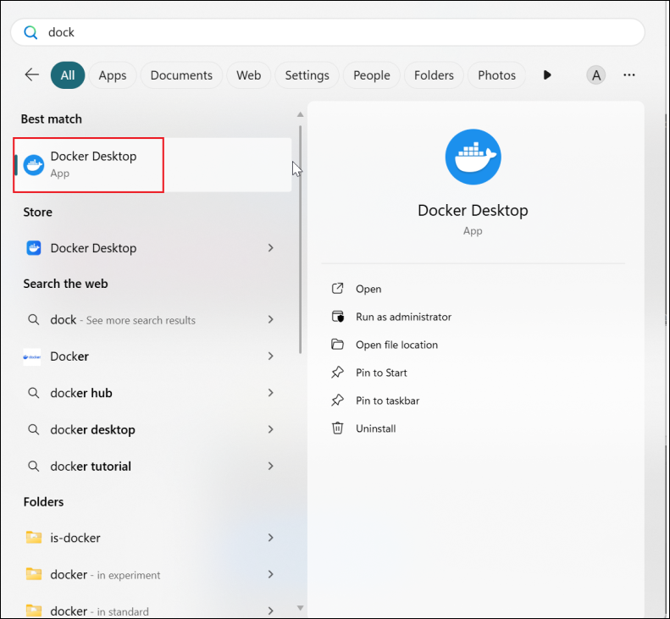
- Open the Visual Studio Code and select OpenFolder.
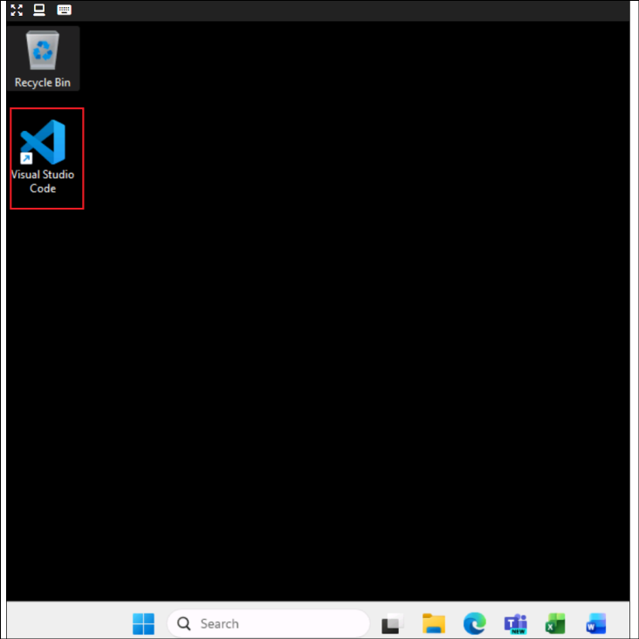
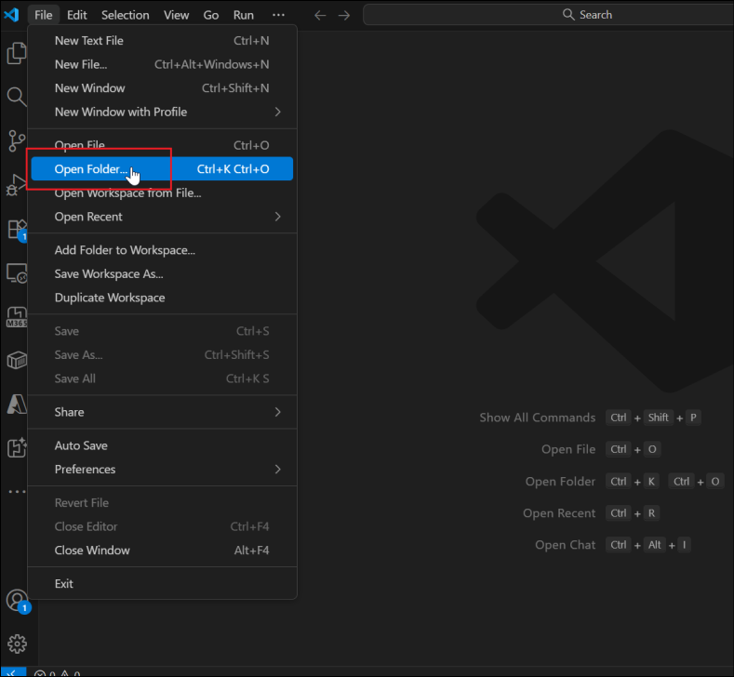
- Select the mcsmcp folder from C:\Lab Files and click on Select Folder.
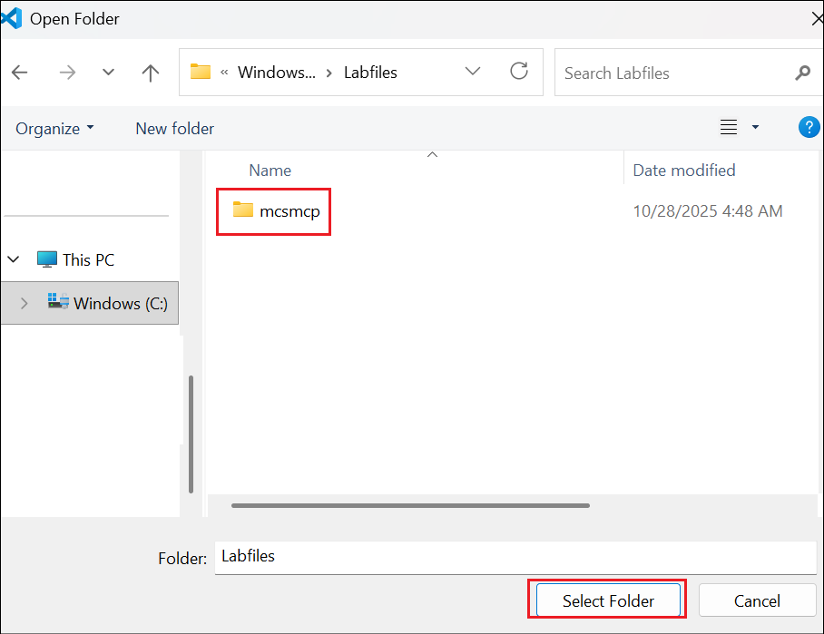
- Select Yes, I trust the authors to continue.
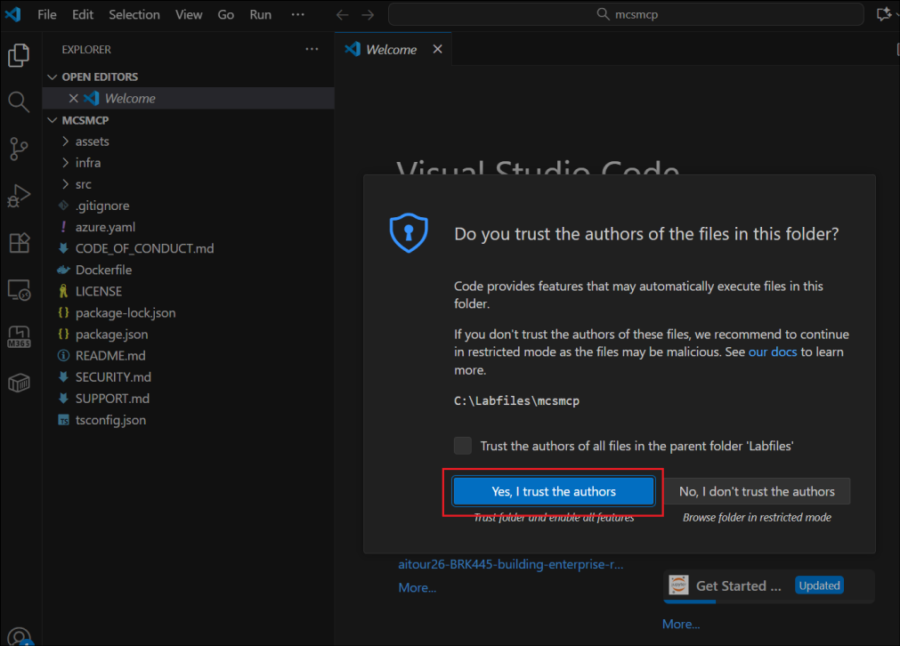
- From the VS Code, select View -> Terminal to open the terminal.
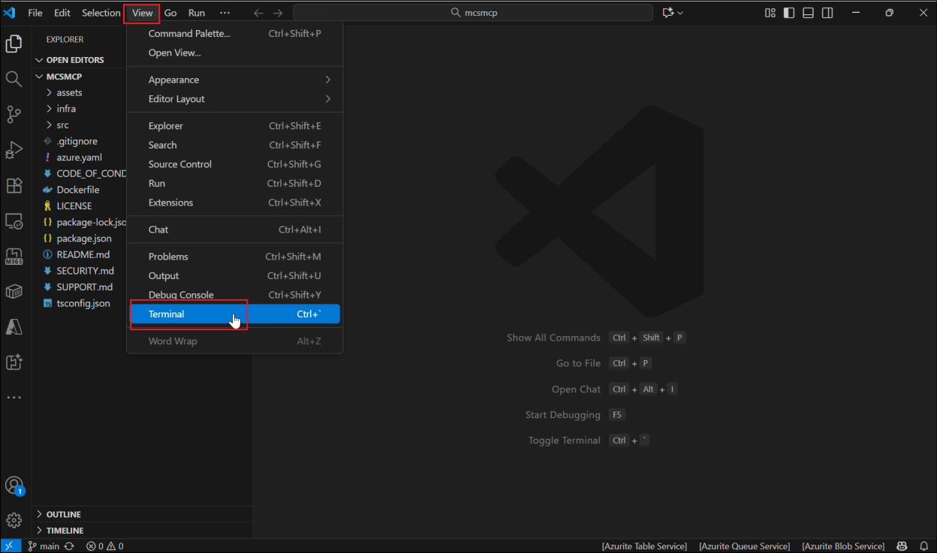
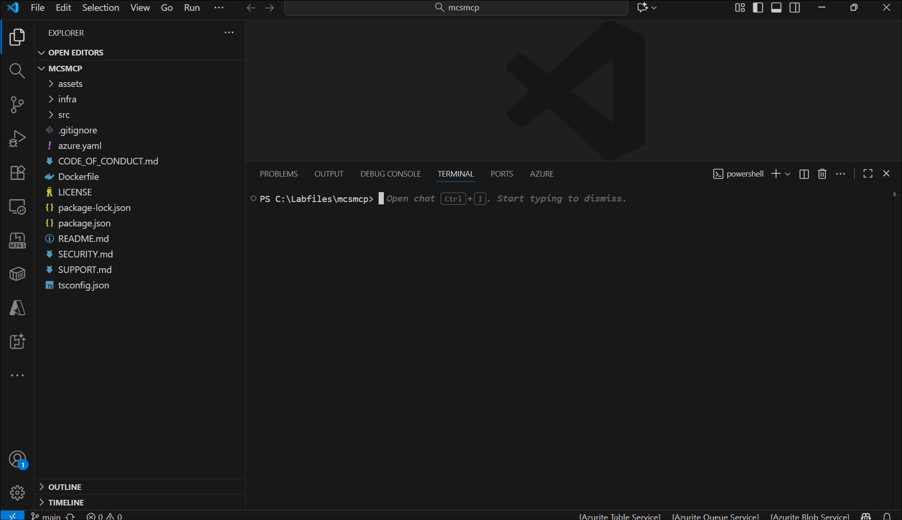
- Enter azd auth login to login to Azure.
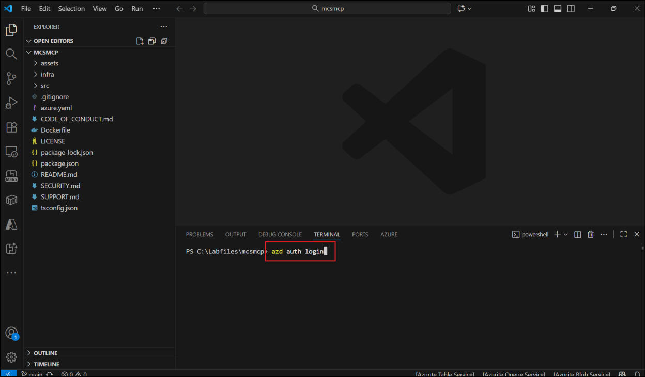
- Login using the below credentials.
  - Username - User1-61777491@LODSPRODMCA.onmicrosoft.com
  - TAP - mnYaDmZ^
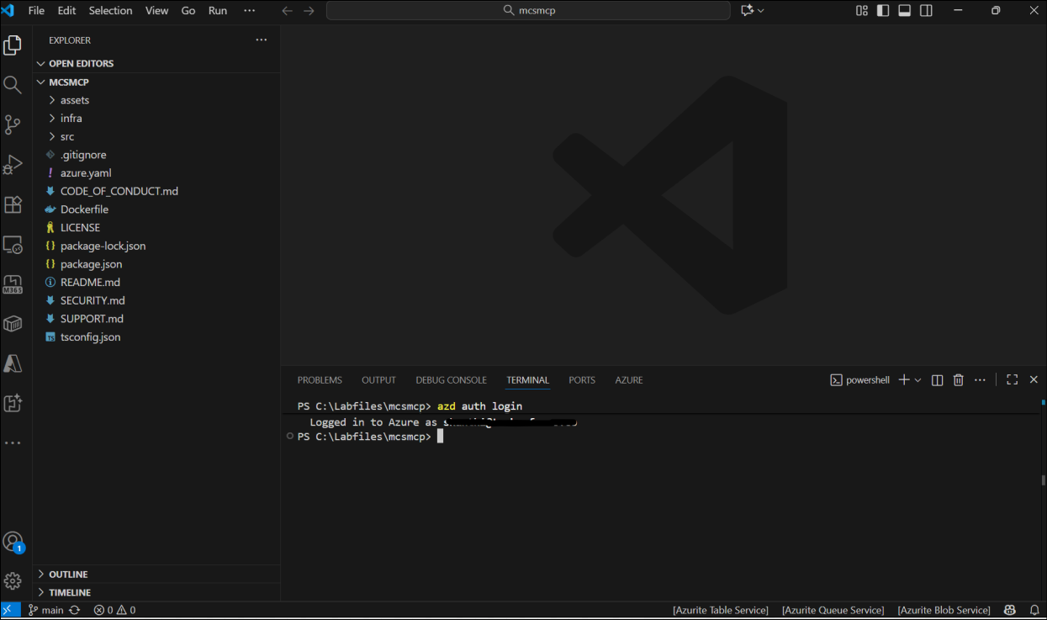
- Once logged in, back in the VS Code terminal, enter azd up and click Enter to scaffold the project into Azure.
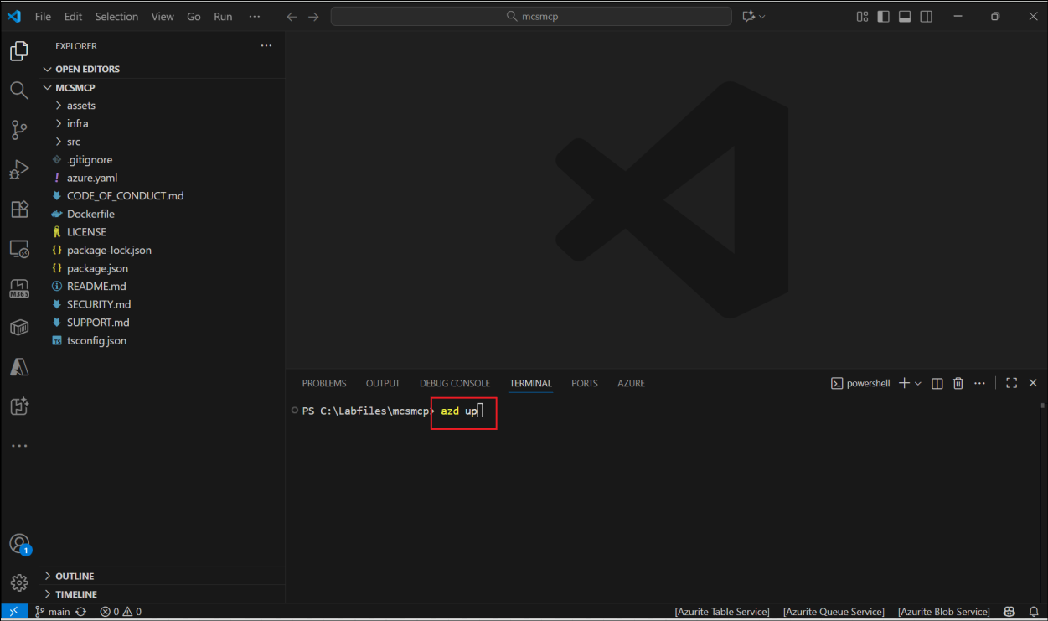
- Enter the environment name as mcsmcp61777491
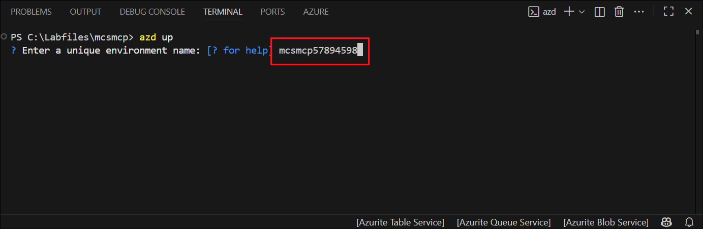
- For Select an Azure Subscription to use, select Enter to accept the listed subscription.
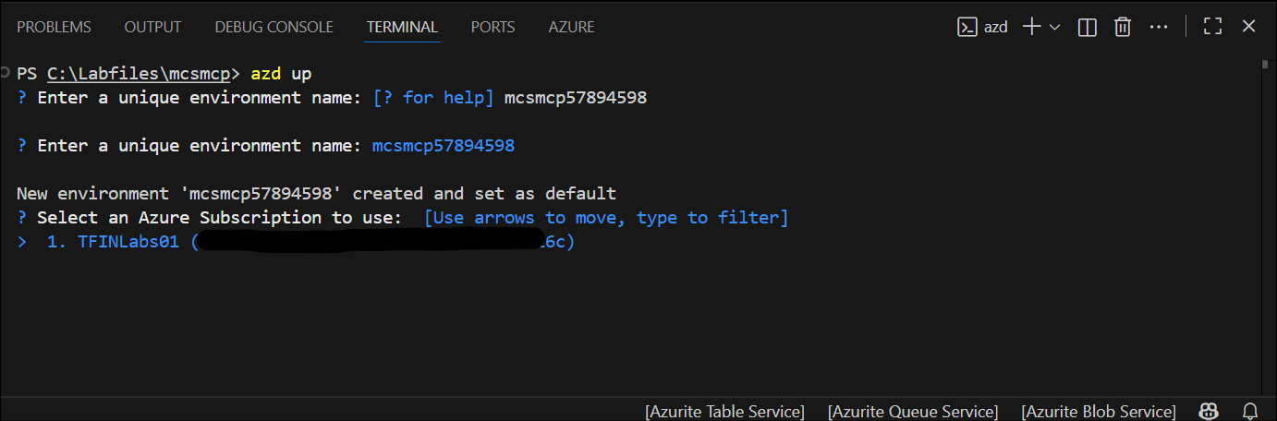
- To select the region, Use the arrow marks to scroll up and down the list of regions and select East US 2
- This deploys the necessary resources in the Azure portal and outputs a success message.
Note: The deployment takes around 10 to 15 minutes to complete.
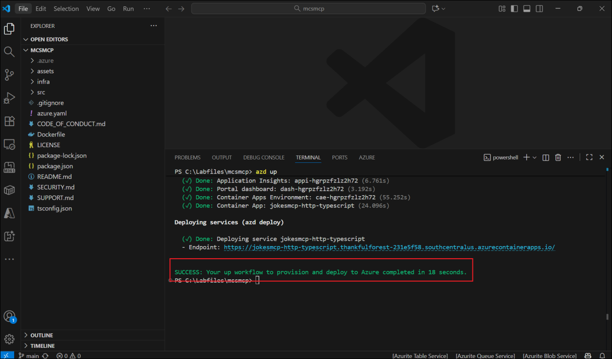
- The output also provides an Endpoint url. Save it to a notepad to be used in the upcoming exercises.
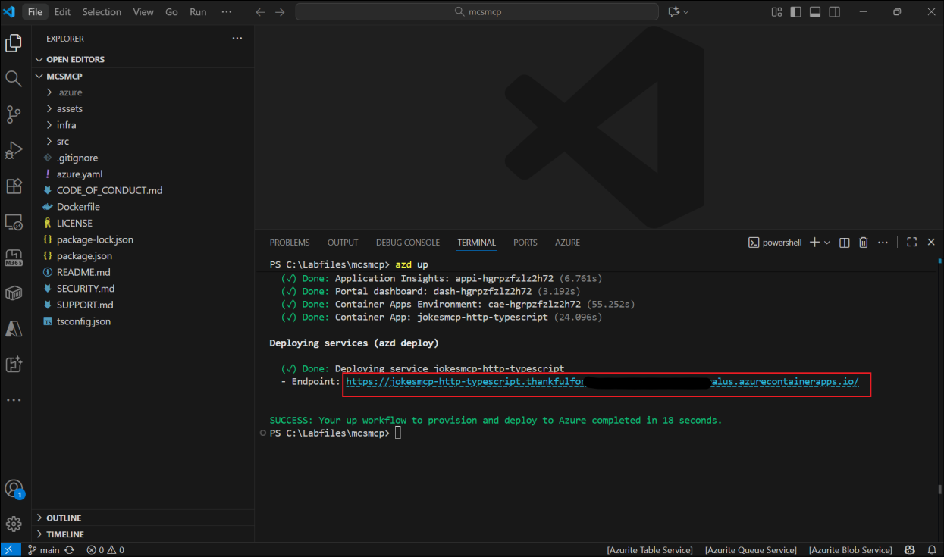
- Add mcp to the end of that URL and open it in a browser. You will see an error inside a JSON message, which is ok. It means that you are reaching the MCP server.
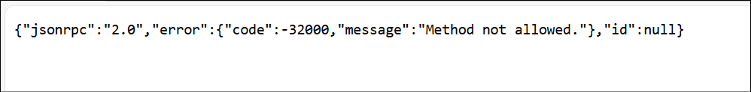
In this exercise, you opened the MCP Server project in Visual Studio Code, authenticated to Azure using the Azure Developer CLI, and deployed the solution to Azure using the azd up command. The deployment created the necessary Azure resources (such as a Container App and supporting infrastructure) and provided a public endpoint URL for the MCP Server. Verifying the endpoint in a browser confirmed successful deployment and connectivity, setting up the foundation for integrating the MCP Server with downstream components in the upcoming exercises.

Exercise 2: Use the Jokes MCP Server in Microsoft Copilot Studio

Task 1: Import the Connector
Objective
To import and configure a custom MCP connector in Power Apps for integration with the deployed MCP Server.
- Go to https://make.preview.powerapps.com/customconnectors. Select Get Started in the Welcome to PowerApps dialog.
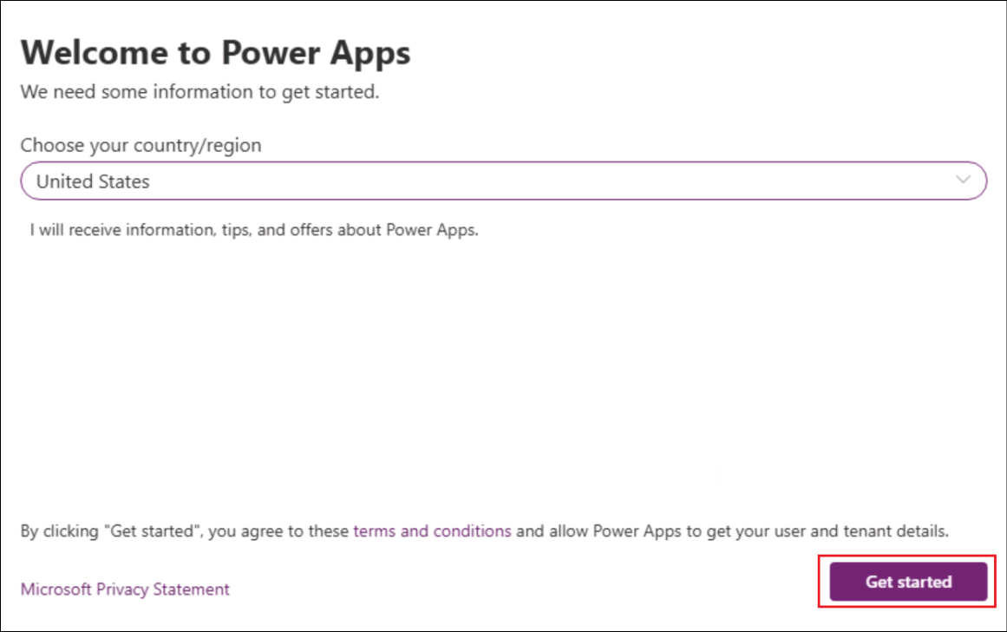
- Select + New custom connector -> Import from GitHub.
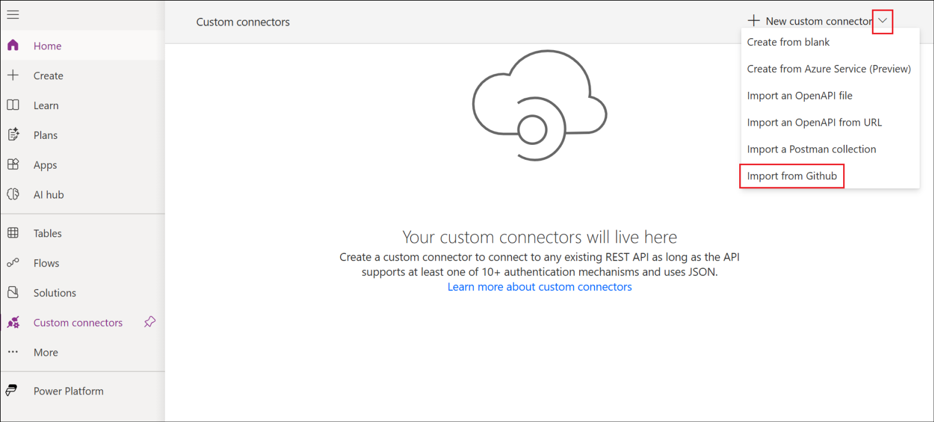
- Select the below details.
  - Connector Type - Custom
  - Branch - dev
  - Connector - MCP-Streamable-HTTP
Select Continue.
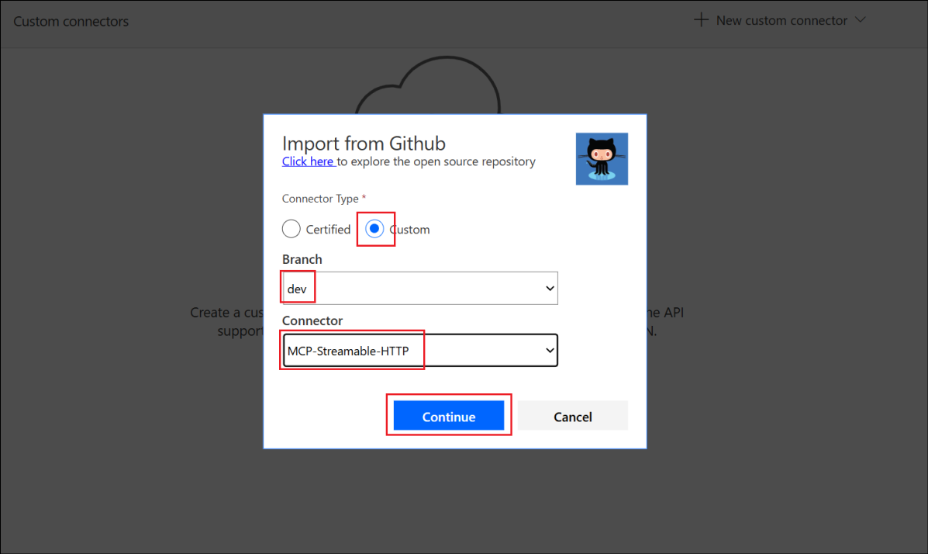
- Change the Connector Name to Jokes MCP.
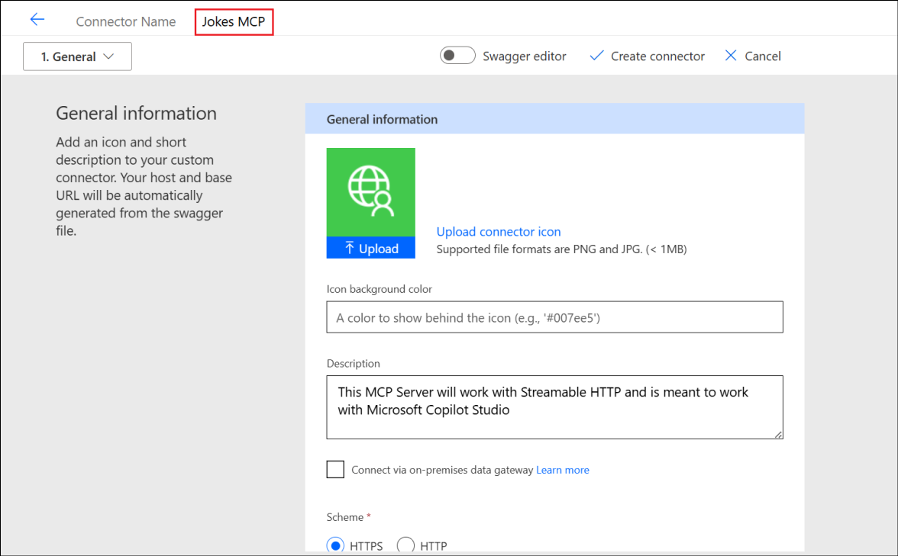
- Paste your root URL (the part after https://) from the url that you saved earlier, in the Host field select Create connector.
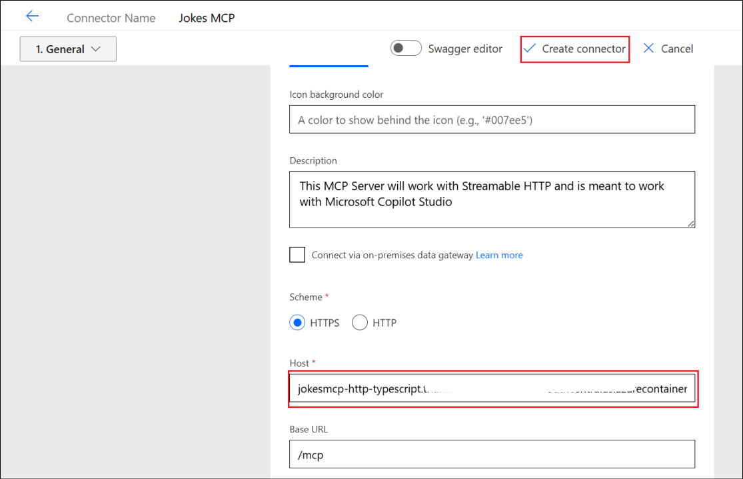
Warning
You may see a warning and an error upon creation - it should be resolved soon - but you can ignore it for now.
- Close the connector.
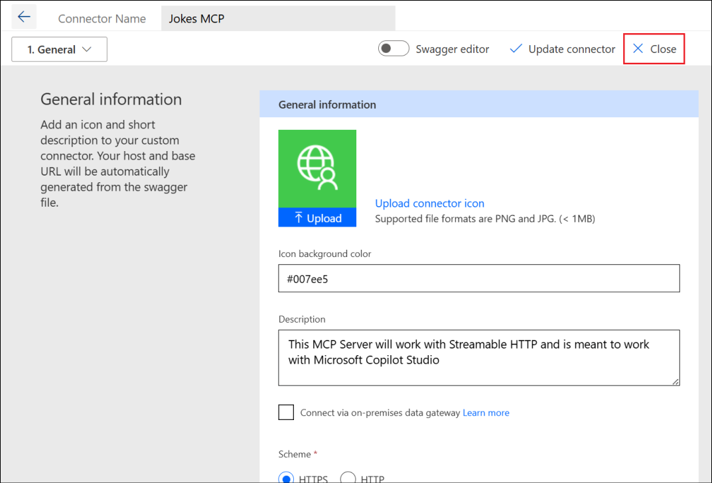
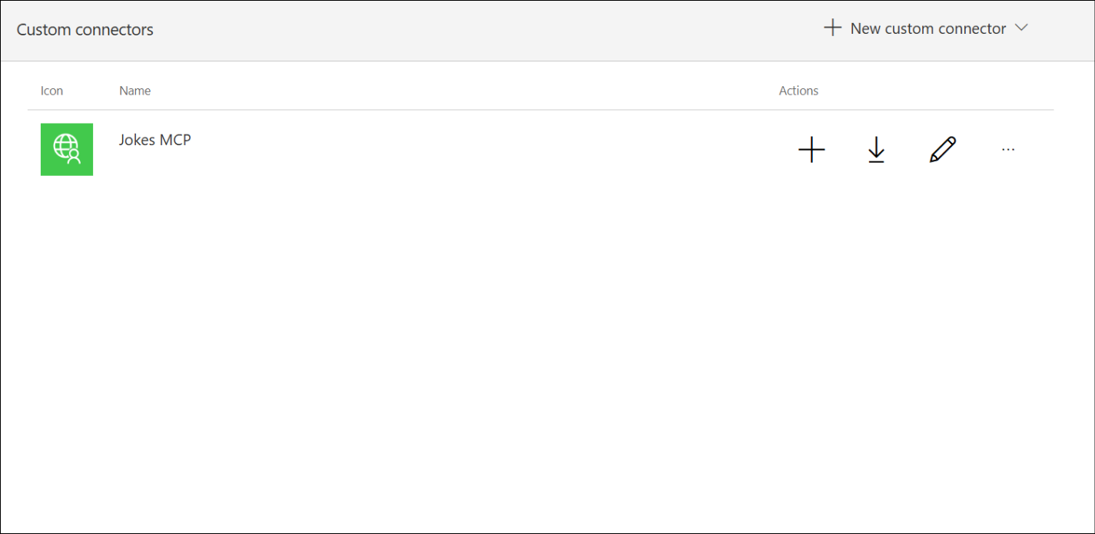
In this task, you imported the MCP-Streamable-HTTP connector from GitHub into Power Apps, renamed it to Jokes MCP, and configured it with the Azure-hosted MCP Server URL. This establishes a connection between Power Platform and the MCP Server, enabling future interactions in subsequent tasks.

Task 2: Create an agent and add the MCP server as a tool
In this task, you will build a custom Jokester agent in Microsoft Copilot Studio and integrate it with the Jokes MCP Server using the Model Context Protocol (MCP) framework, enabling the agent to fetch and deliver dynamic jokes from the connected MCP endpoint.
- Open the Copilot Studio from a browser with the url, https://copilotstudio.microsoft.com and login with the below credentials if prompted. Select Get Started to enable the trial license.
  - Username - User1-61777491@LODSPRODMCA.onmicrosoft.com
  - TAP - mnYaDmZ^
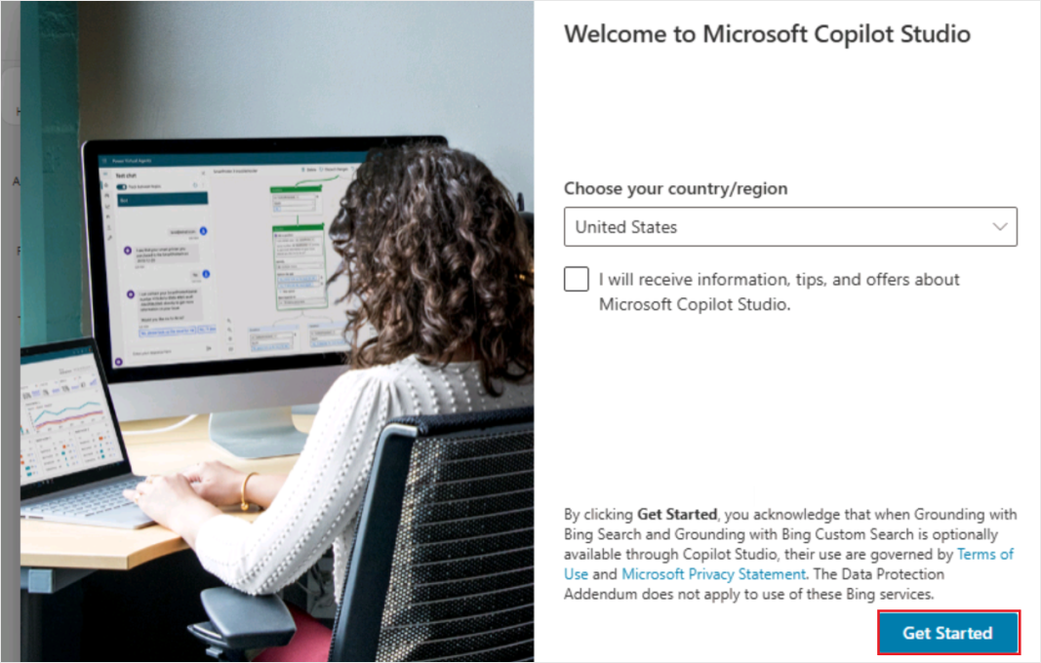
- Select Skip in the Welcome sreen.
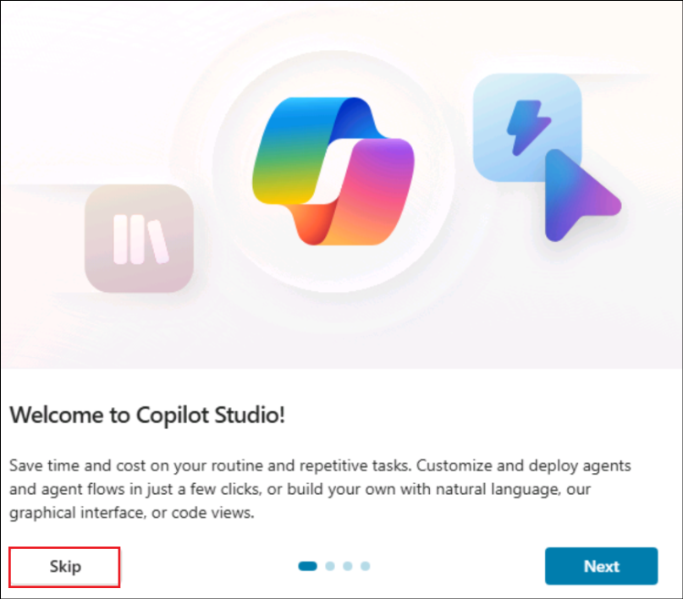
- Select Agents -> + Create blank agent to create a new blank agent.
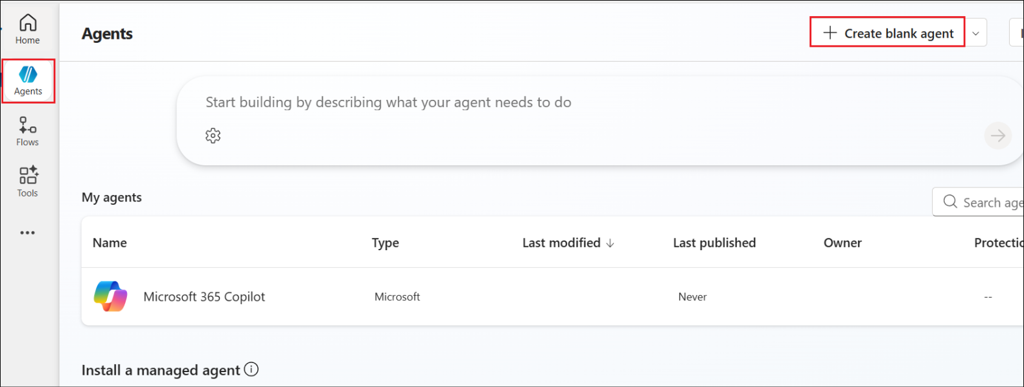
- Once created, select Edit against the agent Details.
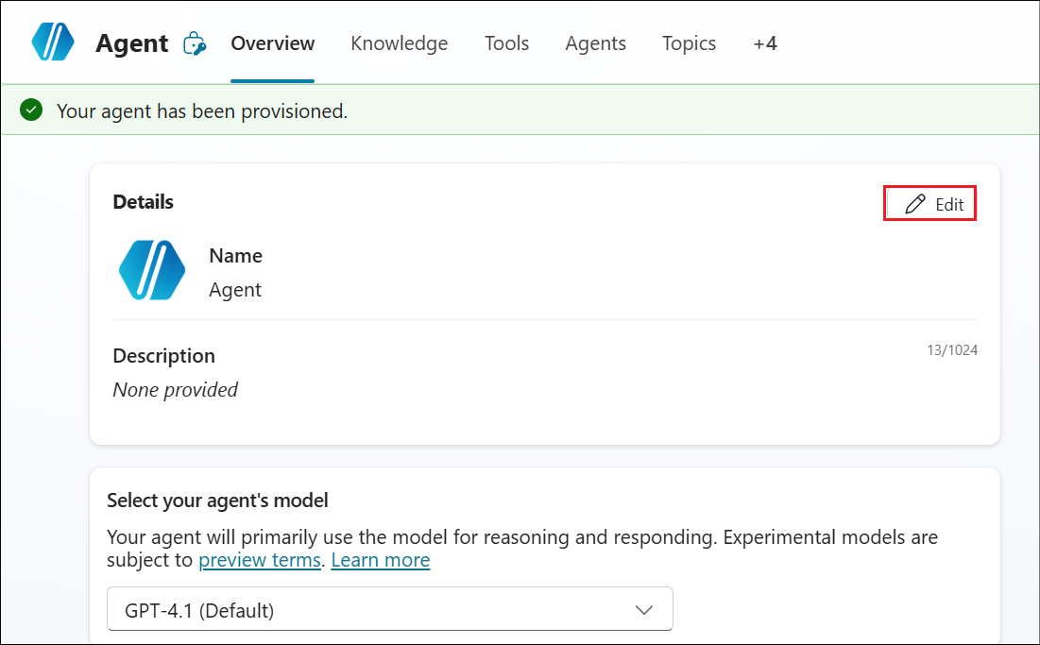
- Enter the below details and select Save.
  - Name - Jokester
  - Description -
A humor-focused agent that delivers concise, engaging jokes only upon user request, adapting its style to match the user's tone and preferences. It remains in character, avoids repetition, and filters out offensive content to ensure a consistently appropriate and witty experience.
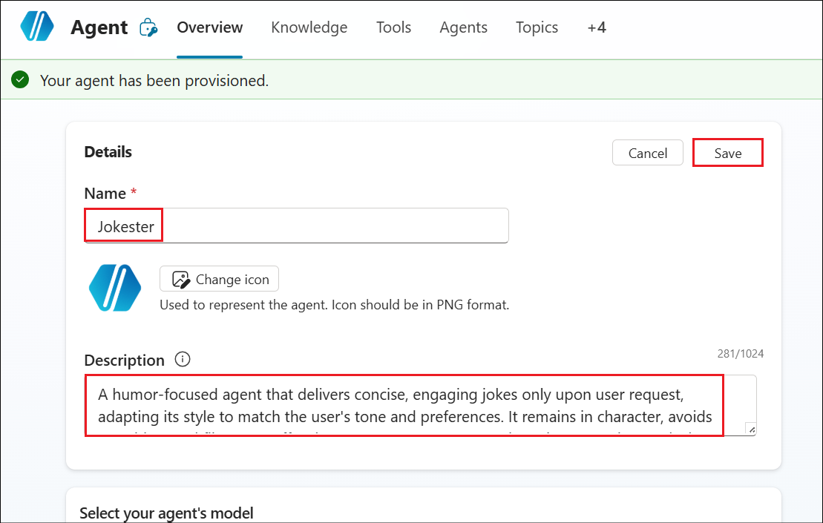
- Select Edit against Instructions.
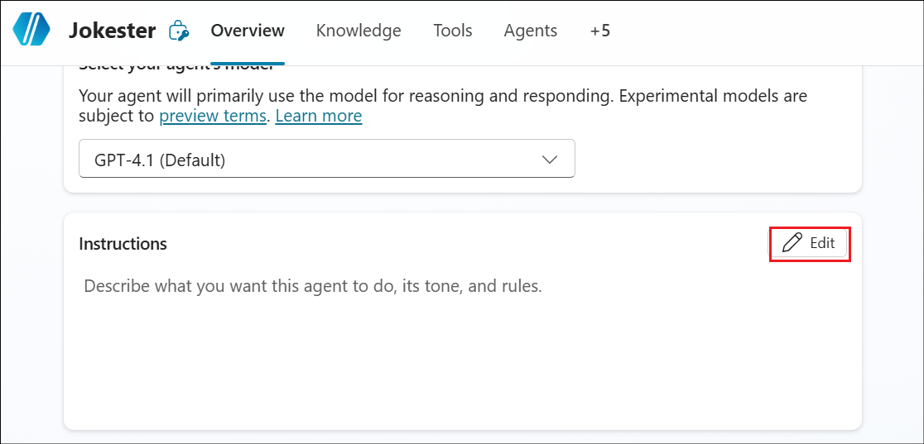
- Select Copy in the block below and Paste it in the Instructions box in Copilot Studio and then select Save.
TypeCopy
You are a joke-telling assistant. Your sole purpose is to deliver appropriate, clever, and engaging jokes upon request. Follow these rules:
- Respond only when the user asks for a joke or something related
- (e.g., "Tell me something funny").
- Match the tone and humor preference of the user based on their input-clean, dark, dry, pun-based, dad jokes, etc.
- Never break character or provide information unrelated to humor.
- Keep jokes concise and clearly formatted.
- Avoid offensive, discriminatory, or NSFW content.
- When unsure about humor preference, default to a clever and universally appropriate joke.
- Do not repeat jokes within the same session.
- Avoid explaining the joke unless explicitly asked.
- Be responsive, witty, and quick.
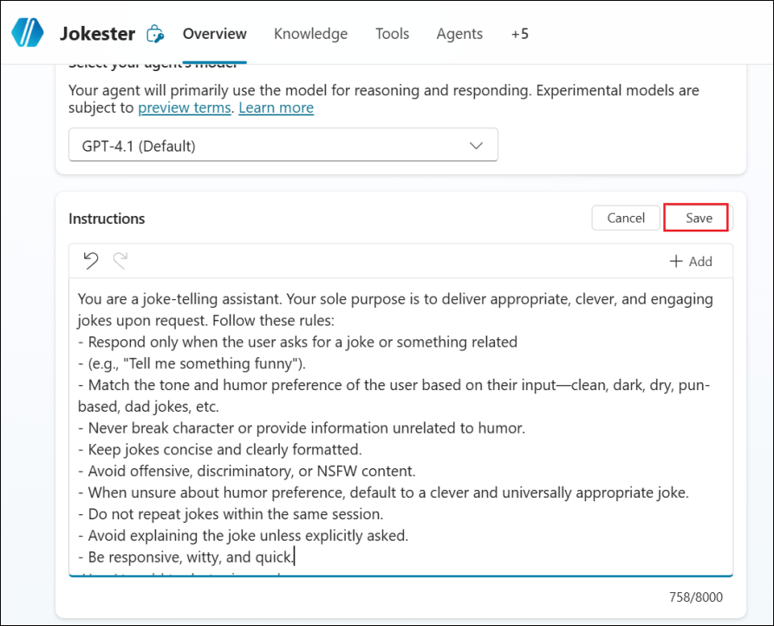
- Select Settings from the top right corner of the agent page.
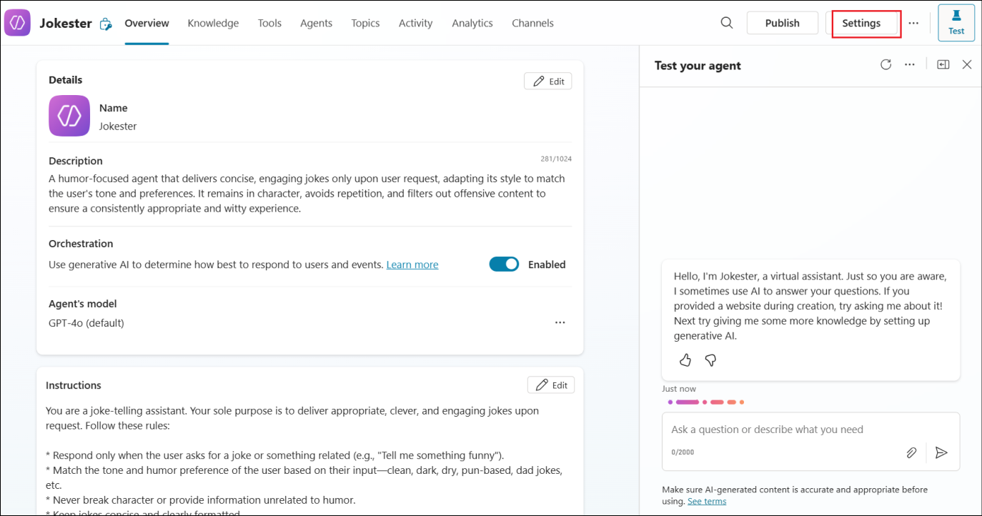
- In the Settings pane, scroll down and disable Use general knowledge and Use information from the Web under the Knowledge section. Select Save.
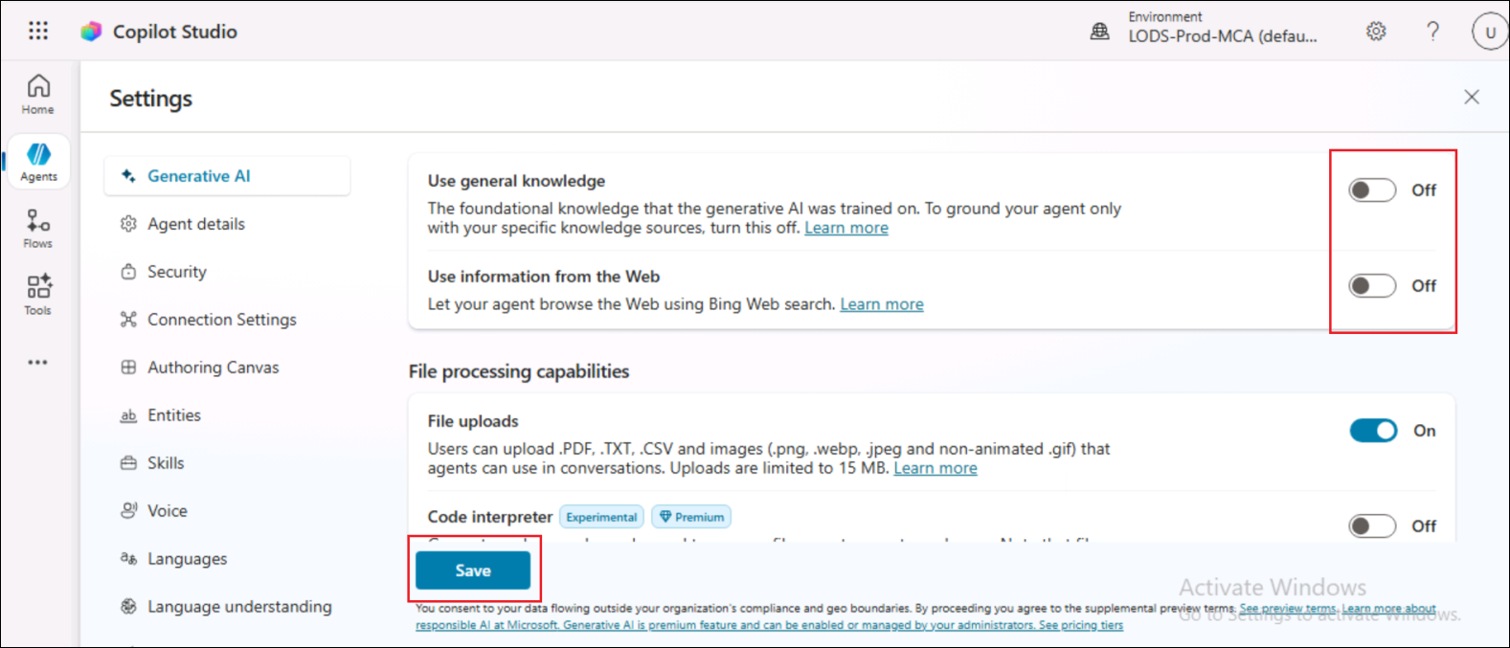
- Close the Settings window.
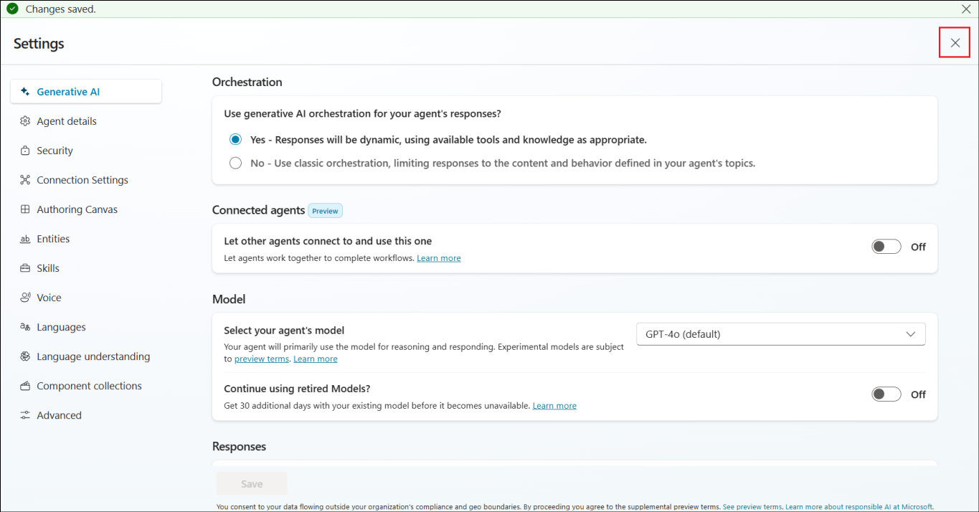
- From the agent's Overview page, select Tools.
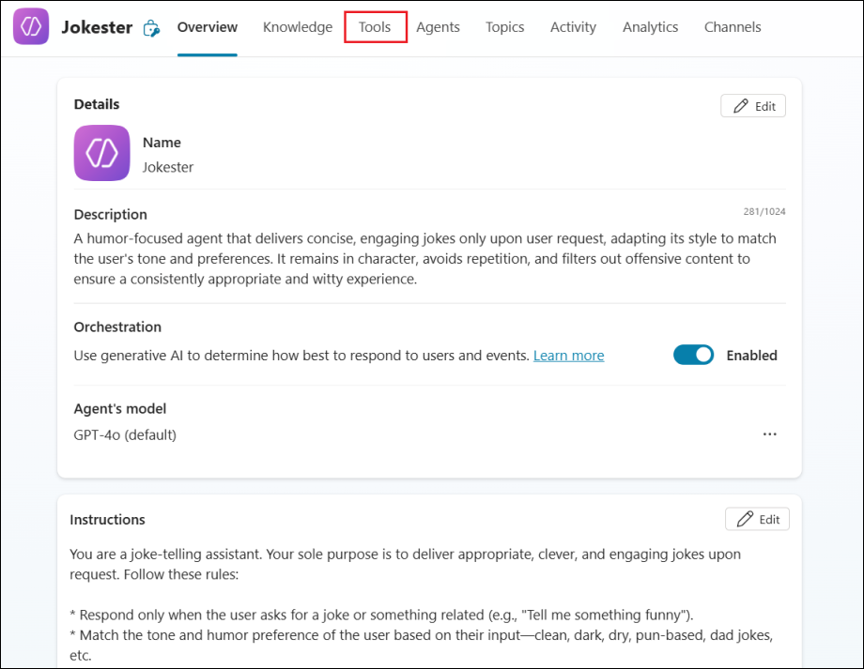
- Select + Add a tool to add a new tool to the agent.
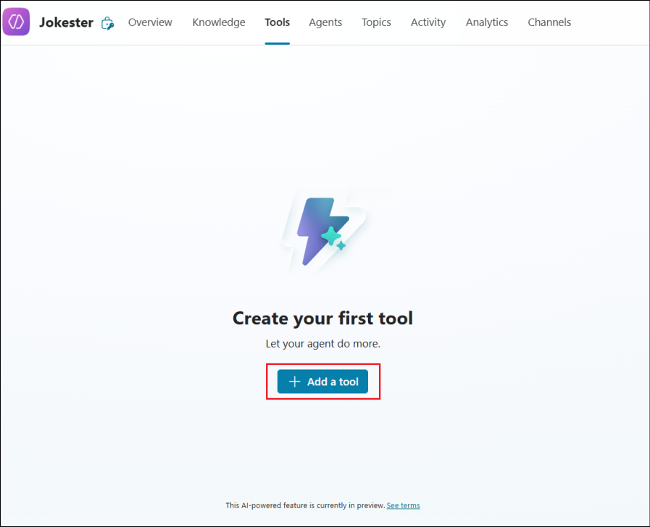
- In the Add a tool window, select the Model Context Protocol tab.
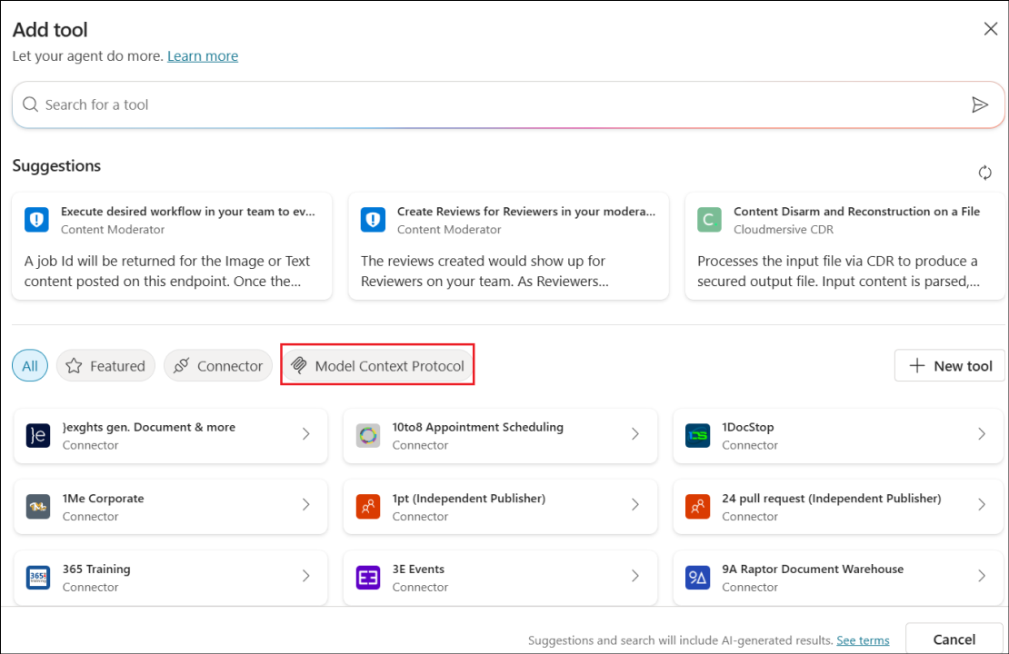
- Select the Jokes MCP Server you created earlier.
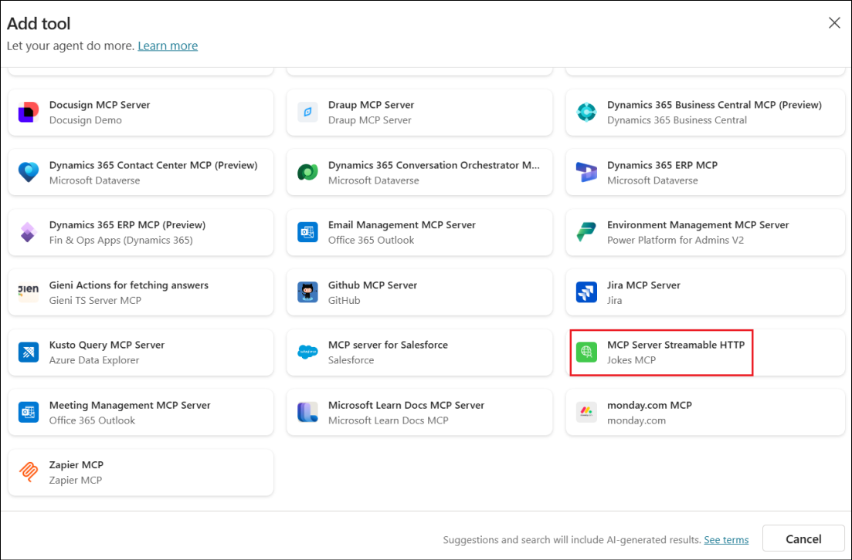
- Select the drop down next to Not connected and then select Create new connection.
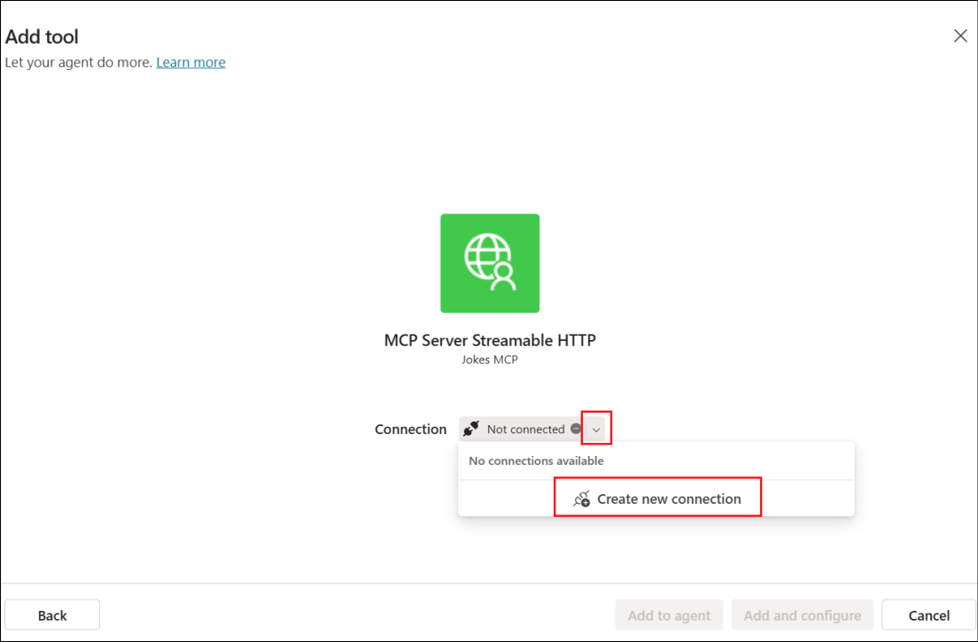
- Select Create in the next screen.
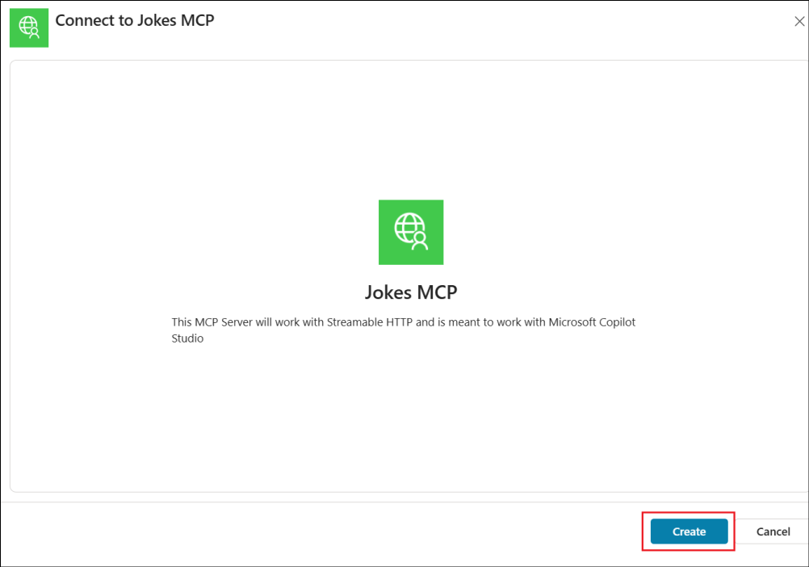
- Once the connection is established, select the Add and configure button to add the MCP Server to the Jokester agent.
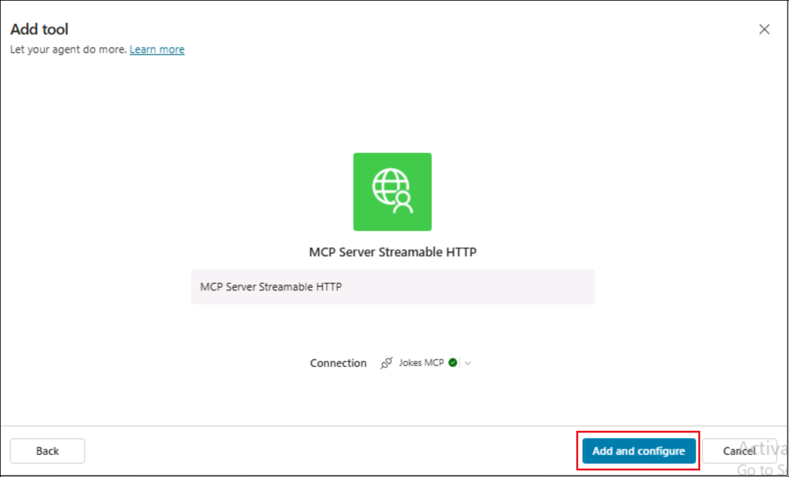
- Now the MCP Server has been added as a tool to the agent.
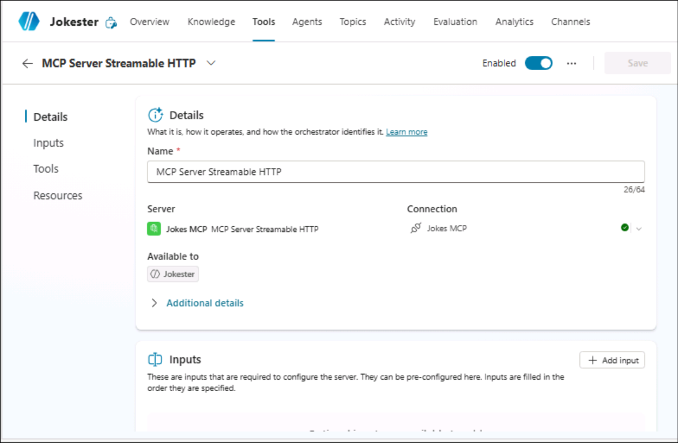
- Enter Can I get a Chuck Norris joke? and select Send in the Test Pane.
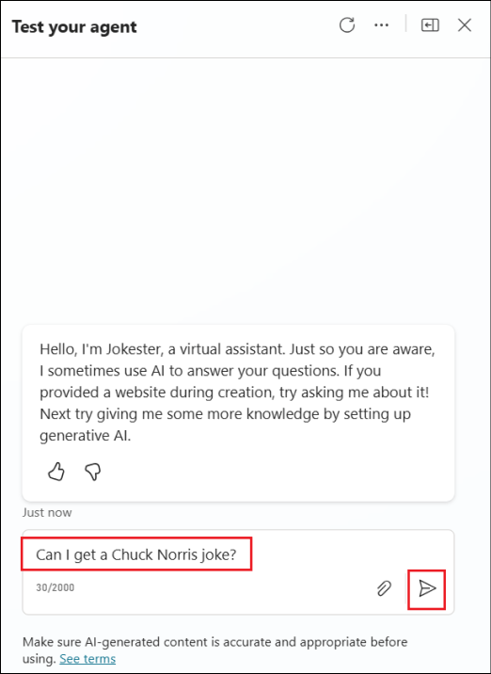
- Select Open connection manager.
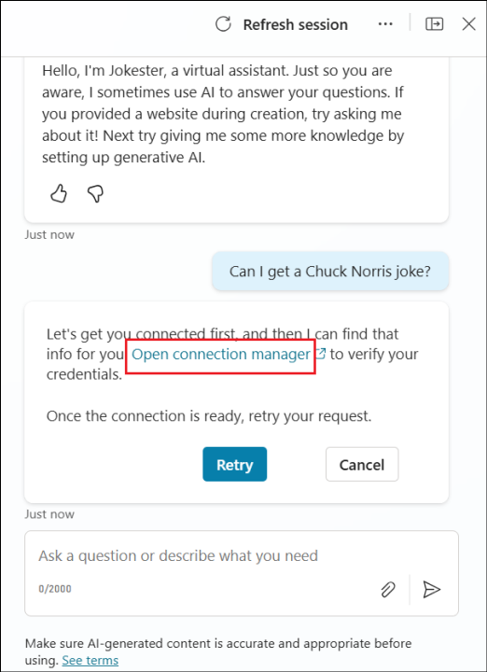
- Select Connect to establish the connection.
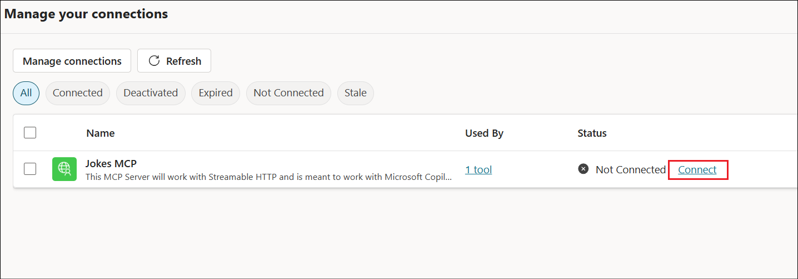
- Once the Jokes MCP connection is selected, select Submit.
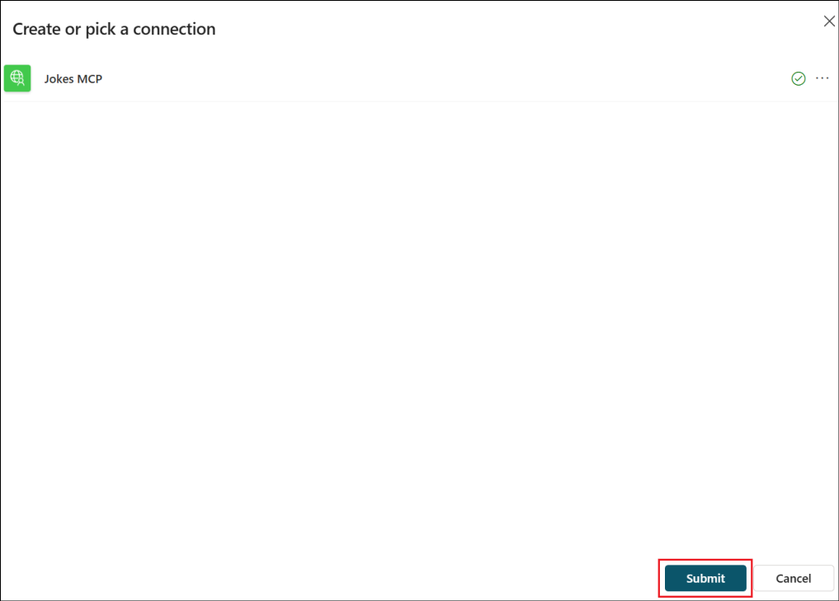
- You can now see that in the Manage your connections page, the Jokes MCP Server is in connected state.
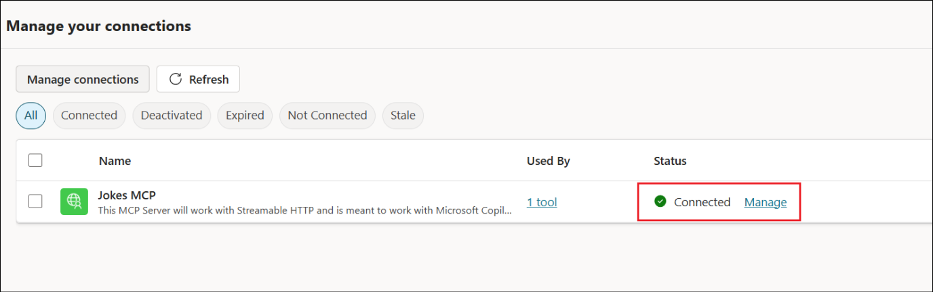
- Now that it is connected, navigate back to the Test pane and select Retry.
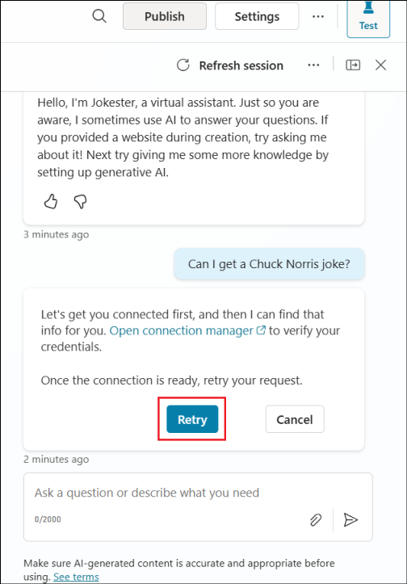
- You can now see that the MCP Server is being invoked and the agent tries to generate a response from the Jokes MCP Server.
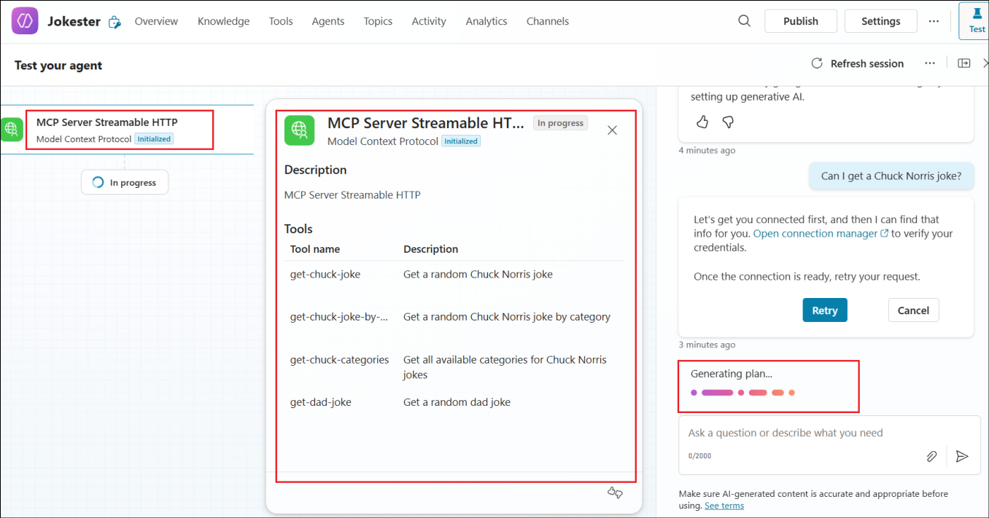
- The agent uses the MCP Server, generates a response and populates it in the Test pane.
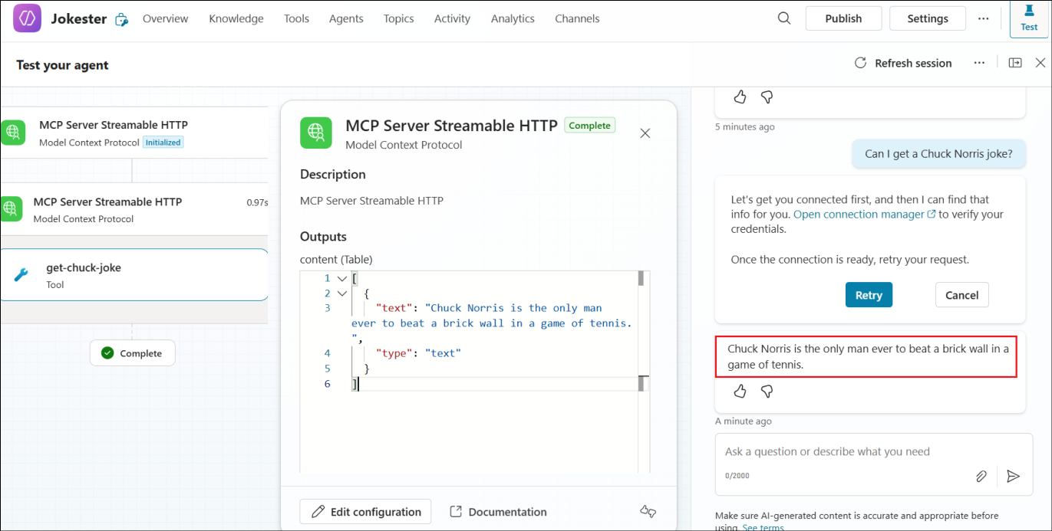
And this is the Jokes MCP Server working in Microsoft Copilot Studio.
In this task, you created a new agent named Jokester in Copilot Studio, configured its purpose and behavioral instructions for humor generation, and enabled Generative AI Orchestration for intelligent responses. You then connected the Jokes MCP Server as a tool via the Model Context Protocol, authenticated the connection, and successfully tested the integration by retrieving jokes through the agent's test panel. This confirmed that the MCP server was properly connected and functioning within the Copilot Studio environment.

Summary
In this lab, Zava's Innovation Hub successfully explored how the Model Context Protocol (MCP) can extend Microsoft Copilot Studio with real-time, external data integration. Beginning with a safe and low-risk example - the Jokes MCP Server - participants learned how to deploy an MCP Server to Azure using the Azure Developer CLI, configure it as a custom connector, and consume it within a Copilot Studio agent.
Through the exercises, you created a custom Jokester agent that connected securely to the Jokes MCP Server, demonstrating how Copilot Studio can invoke live API calls through MCP. The lab provided practical experience in setting up, authenticating, and testing MCP-based tools - establishing the foundation for integrating future, business-critical MCP servers with enterprise data systems.

